Sarah Martin @SMCLtdMaths

To be kept updated with new resources, ideas and activities please follow me on Twitter.

EYFS – Erikson Math

Erikson Math – website with ideas, suggestions, videos and resources to explore with younger children linked to Maths at hoe e.g. 5 Ways to Build Math into Your Child's Day. The Idea Library is useful too.
https://earlymath.erikson.edu/

Follow on Twitter for daily suggestions and ideas - https://twitter.com/eriksonmath
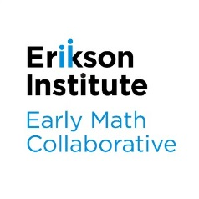

EYFS and Y1 - Numberblocks

Numberblocks is a pre-school BBC television series aimed at introducing children to early number.
Snappy animation and loveable characters combine with engaging storylines to gently introduce concepts of number to support early mathematical understanding. The NCETM materials help children to bring the numbers and ideas to life in the world around them.

https://www.ncetm.org.uk/resources/52060

Follow on Twitter for daily suggestions and ideas from other children and parents. There are also apps to download - https://twitter.com/numberblocks

Y1 – Y6 children – Study Maths

Hundreds of randomly generated, self-marking worksheets for independent practice to help children keep facts and recall ‘bubbling’.

https://studymaths.co.uk/workoutMenu.php

Y1 – Y8 children – White Rose Hub

The White Rose Maths Team has prepared a series of five brand new maths lessons for each year group from Years 1-8. Every lesson comes with a short video showing you clearly and simply how to help your child to complete the activity successfully. More lessons to follow.

Just follow these four easy steps…
- Click on the set of lessons for your child’s year group.
- Watch the video (either on your own or with your child).
- Find a calm space where your child can work for about 20-30 minutes.
- Use the video guidance to support your child as they work through a lesson.

https://whiterosemaths.com/homelearning/

Follow on Twitter to be notified when new lessons and resources are available to use at home
https://twitter.com/WhiteRoseMaths
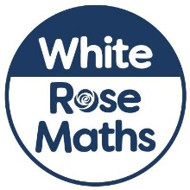

Y1 – Y6 children BBC Bitesize

There is a range of free resources for children created and written with teachers, right across the Key Stages and curriculum subjects. Ideas, resources, video clips and games to play linked to different aspects of mathematics e.g. number, measurement and shape.
https://www.bbc.co.uk/bitesize/primary

Follow on Twitter - https://twitter.com/bbcbitesize

EYFS – Y6 Nrich

Presently putting together a collection of the best NRICH resources to support independent learning - watch this space! Problem solving activities and games for children to explore and try out their problem solving skills.
https://nrich.maths.org/

Follow on Twitter to be updated on when the resources are ready - https://twitter.com/nrichmaths

