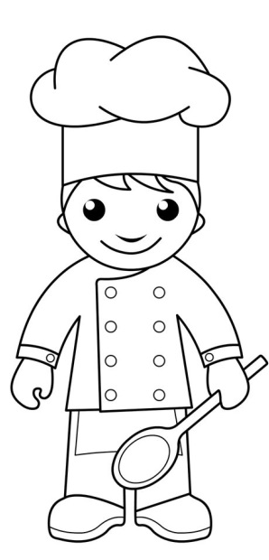
Design and colour in the Chef to make it look like you.
You can even add more hair if you need to! You could also do one for the person helping you in the kitchen. Don’t forget to send them back into school to show your teachers.

