**Eight tips for healthy eating**

Do you remember the eight tips for healthy eating?

Fill in the blanks below and draw a picture for each tip.

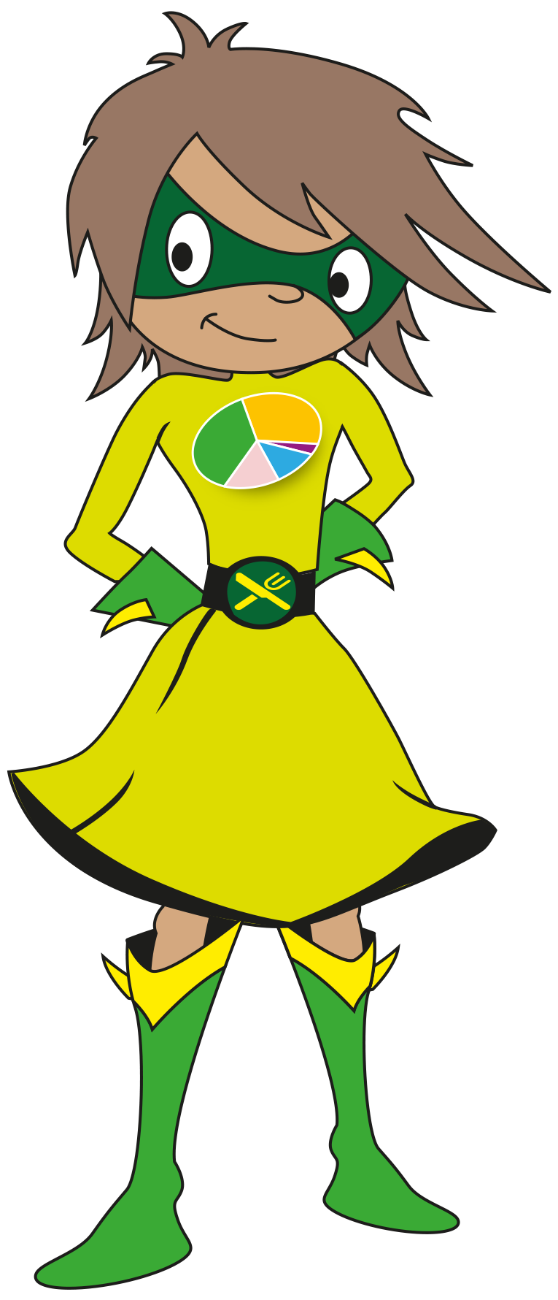

Base your meals on

__________ foods.

Eat lots of fruit and

__________.

Eat more __________.

Cut down on

__________ fat

and __________.

Eat less

__________.

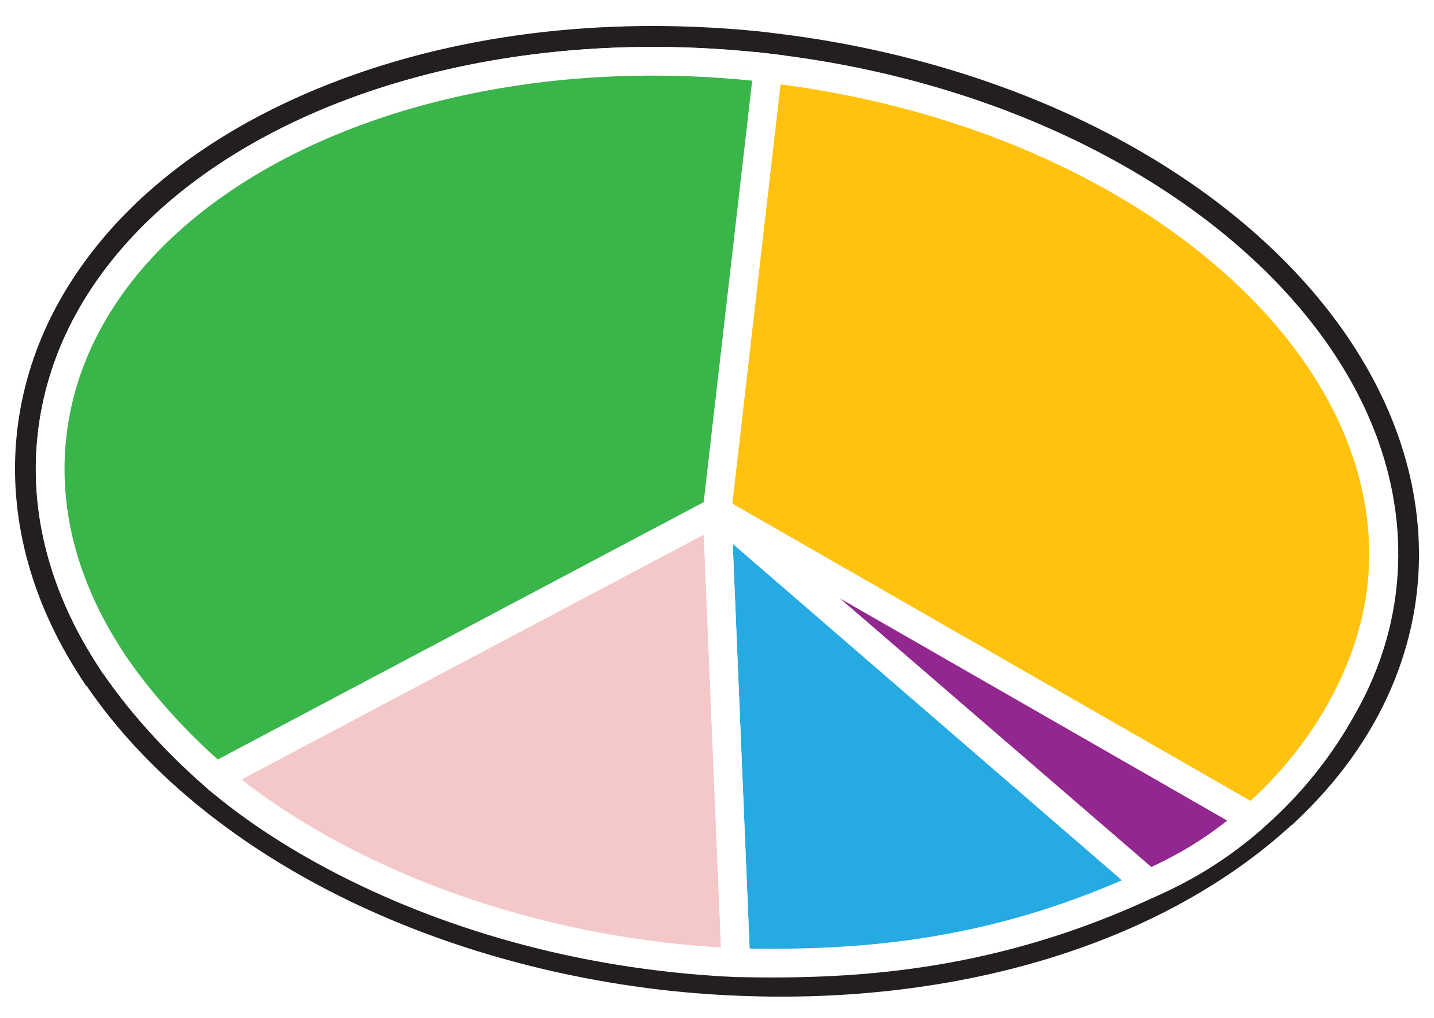

Don't skip

__________.

Don't get

__________.

Get __________

and be a __________

weight.

© Crown Copyright 2016