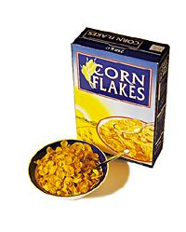

Food labels
Do you know what a food label tells you? Fill in the blanks with the correct words.
N_ _ _ _ _ _ _ _ Information
(per 100g)
Energy | 1518 kJ/  359 kcal
Fat  saturates | 4.6g  0.6g
Carbohydrates | 70.0 g
sugars | 25.0 g
Fibre | 8.9 g
Protein | 9.3g
Salt | 0.63 g

N_ _ _ of product:
Corn flakes

B_ _ _ B_ _ _ _ _:
30 June 2015
Name and a_ _ _ _ _ _ of manufacturer:
Produced by
Healthy Foods Co.
London WC16RQ
W_ _ _ _ _ of product:
450 g
I_ _ _ _ _ _ _ _ _ _:
Maize, Sugar, Barley Malt Flavouring, Salt, Vitamins & Minerals: Niacin, Iron, Vitamin B6, Vitamin B2 (Riboflavin), Vitamin B1 (Thiamin), Folic Acid, Vitamin D, Vitamin B12.
Country of o _ _ _ _ _:
Produce of the USA.
S _ _ _ _ _ _:
Store in a cool, dry place.

