

**10th September 2021**

**A weekly newsletter to share the news of Pinehurst Primary School**

**THE PINEHURST PRESS**

**Experience ~ Excel ~ Enjoy**





At the end of our first full week at school a BIG well done to everyone, and thank you once again for your patience as we adapt to the return to school and new COVID guidance.

We are all adapting really well to being back in school. Our soft start is helping to ensure children are settled in class and ready for learning at 8.55am. Remember children can arrive between 8.40am and 8.55am to start the school day. Allocated gates for pick up are starting to work well and ensure that we don’t have large crowds in one place on the playground.

The children have settled back into our lunchtime arrangements are enjoying alternating between hot and cold lunch options.

Our Breakfast Club provision has started for working parents to provide wraparound care.

Our cautious approach is because we have an essential role to play in limiting the spread of the Coronavirus and ask for your help in doing this.

**If your child has a cough, high temperature (above 37.8 degrees) or a loss of taste or smell they must stay off school and get PCR tested for COVID19.**

If your child is absent from school for any reason we ask that you contact school EVERYDAY to provide us with the reason and an update that they are safe at home.

**Weekly Attendance**





|  |  |  |
| --- | --- | --- |
| **Year Group** | **Class** | **Attendance %** |
| 1 | **Elm** | **94.62%** |
| 1 | **Cherry** | **93.91%** |
| 2 | **Fir** | **99.24% ☺** |
| 2 | **Yew** | **94.23%** |
| 3 | **Cedar** | **89.17%** |
| 3 | **Hazel** | **92.19%** |
| 4 | **Chestnut** | **99.09%** |
| 4 | **Holly** | **98.13%** |
| 5 | **Maple** | **88.40%** |
| 5 | **Sycamore** | **98.52%** |
| 6 | **Birch** | **82.76% ☹** |
| 6 | **Willow** | **98.21%** |



School attendance is IMPORTANT. If you are well you should be in school EVERY DAY.

Whole School 93.55%



Introducing the Senior Leadership Team

  

Miss Morris Miss Thomas Mrs Steers

Headteacher Assistant Assistant

Headteacher Headtacher

EYFS Lead SENDCO

  

Ms MacDiarmid Miss Fry Miss Hamilton

KS1 Lead LKS2 Lead UKS2 Lead

Years 1/2 Years 3/4 Years 5/6

Pupil Premium Curriculum Assessment



A special welcome to our Early Years children who have joined the Pinehurst Family this week.

It has been wonderful to see them settle into school life this week. They have really enjoyed getting to know each other, finding their way around school and learning the routines of the different settings.

Well done to everyone in Oak, Ash, Little Acorns and Little Pine Cones.



**IF ANY OF YOUR CONTACT DETAILS OR EMERGENCY NUMBERS HAVE CHANGED, PLEASE CONTACT THE OFFICE IMMEDIATELY. THANK YOU**

 **ATTENTION YEAR 6 PARENTS and CARERS**

**Secondary School Transfer for Year 7**

**Applications for Year 7 places for September 2022 are now open.** **Visit your Local Authority Admissions page for further information:**

**https://liverpool.gov.uk/admissions**

**https://sefton.gov.uk/admissions**

**https://www.knowsley.gov.uk/schooladmissions**



**Supporting learning at home…**

Please take some time to practise counting with your child. Reciting number bonds and times tables would be very helpful too. This will help and support them with their learning in school.

**Helpful Reminders**

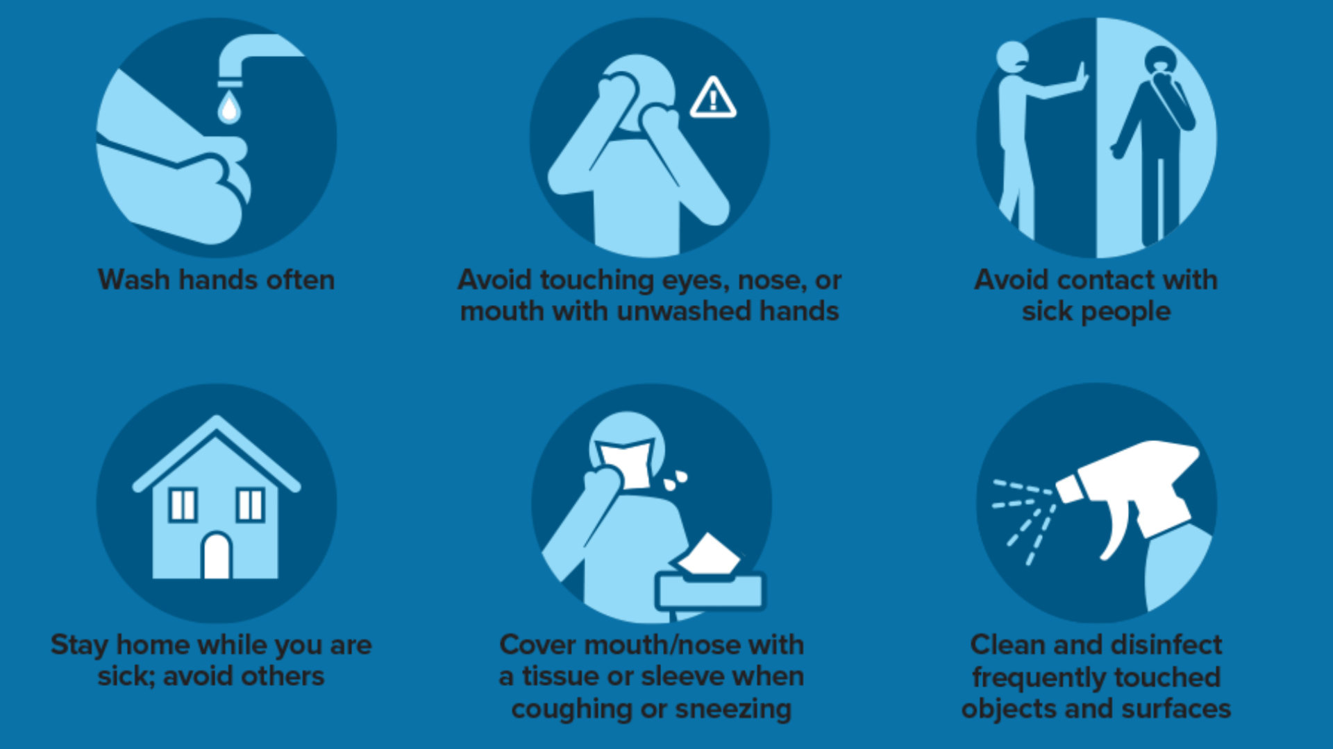



**Please try to ensure that you distance from other adults and families at drop off and pick up.**

**You may choose to wear a face covering at pick up / drop off.**

**Thank you for your cooperation**.

**School Contact Number 07858 739336 for Emergencies only**

**Flu can spread very easily, which is why Children are given a vaccine as protection.**



**There is a special flu vaccine which works really well in children**

**It is given by a painless nasal spray and offered to all school children (Reception to Y 11)**

**This is planned to be offered to Pinehurst Pupils on 15TH OCTOBER 2021**

**Please ensure you have given your email address to the school office so you can receive your Childs electronic consent**

**If you have any questions please contact the immunisation team on**

**0151 295 3833**

**As well as protecting your child against flu, having the vaccine helps stop flu spreading to your family and friends.**

